Raffles Teh Weihan

1.

a. As the child class, species inherited from genus, which is the super class.

b. Without species, specimens cannot exist, this is due to composition.

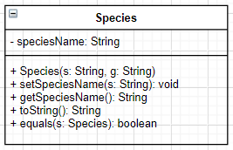c.

d. - Due to inheritance, species can reuse codes from genus.

- Due to composition between specimen and species, instance of species class can be manipulated.

e.

i. Because the toString() method in genus gets override by the ones in species.

ii. Overriding.

2.

a. To hide values in a class, to prevent unauthorized users to access it.

b. - Simplifies maintenance.

- protects objects from unauthorized users.

c. getCage()

d. cageNumber

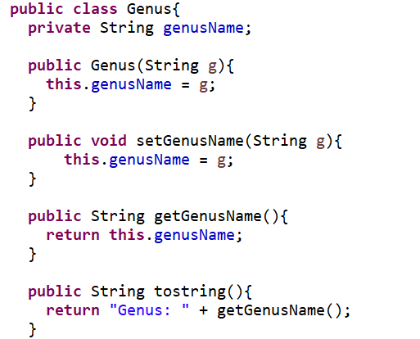e.

f. Advantage: Can reuse the get and set method from species.

Disadvantage: too many supers classes could lead to memory wastage.

3.

a. Add a new private instance variable in the specimen class, then let the user specify the specimen’s markings, then add getter and setter, then edit the toString() method to accommodate the new variable.

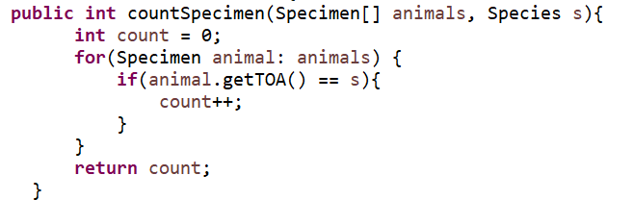b.

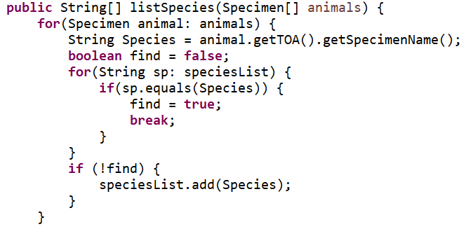c.

4.

a. It helps store data and has a functional system with methods.

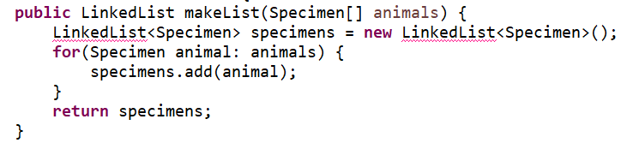b.

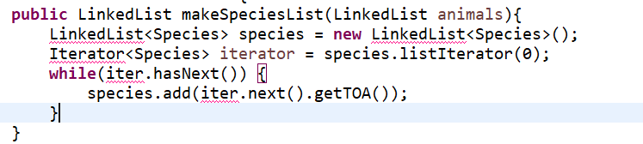c.

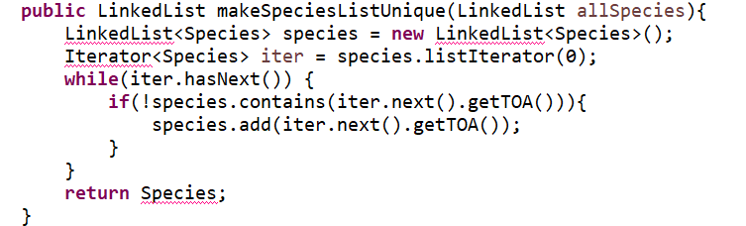d.